

Mobile Application Development

Lab 6



Muhammad daniyal Qureshi

021-18-0009

BSCS-VII

Contents

Activity 1: MadLibs using Files 1

**Layout** 1

**Logic Code** 4

**Output** 8

Activity 2:Add Contacts in Database 12

**Layout** 12

**Logic Code** 16

SQliteOpenHelper Class: 17

**Output** 19

# Activity 1: MadLibs using Files

## **Layout**

<?xml version="1.0" encoding="utf-8"?>

<LinearLayout xmlns:android="http://schemas.android.com/apk/res/android"

    xmlns:app="http://schemas.android.com/apk/res-auto"

    xmlns:tools="http://schemas.android.com/tools"

    android:layout_width="match_parent"

    android:layout_height="match_parent"

    android:orientation="vertical"

    tools:context=".MainActivity">

    <ImageView

        android:id="@+id/imageView"

        android:layout_width="match_parent"

        android:layout_height="wrap_content"

        app:srcCompat="@drawable/cover" />

    <TextView

        android:id="@+id/textView"

        android:layout_width="match_parent"

        android:layout_height="wrap_content"

        android:gravity="center"

        android:padding="10dp"

        android:text="Welcome to Mad Libs! I will ask you to fill in words to complete the story until you are done filling in all the missing words. That's part of the fun. Click below to get started..."

        android:textColor="@color/black"

        android:textSize="18sp" />

    <Button

        android:id="@+id/btnst"

        android:layout_width="wrap_content"

        android:layout_height="wrap_content"

        android:layout_gravity="right"

        android:onClick="start"

        android:text="GET STARTED!"

        android:textColor="@color/black"

        android:textSize="30sp"

        android:textStyle="bold"

        android:backgroundTint="#808080"

        />

</LinearLayout>

<?xml version="1.0" encoding="utf-8"?>

<ScrollView xmlns:android="http://schemas.android.com/apk/res/android"

    xmlns:app="http://schemas.android.com/apk/res-auto"

    xmlns:tools="http://schemas.android.com/tools"

    android:layout_width="match_parent"

    android:layout_height="match_parent"

    android:fillViewport="true"

    tools:context=".story">

<LinearLayout

    android:layout_width="match_parent"

    android:layout_height="match_parent"

    android:orientation="vertical"

    >

    <TextView

        android:id="@+id/textView4"

        android:layout_width="wrap_content"

        android:layout_height="wrap_content"

        android:layout_gravity="center"

        android:layout_weight="0"

        android:text="Your Mad Lib Story"

        android:textSize="36sp"

        android:textStyle="bold" />

    <TextView

        android:id="@+id/textView5"

        android:layout_width="match_parent"

        android:layout_height="wrap_content"

        android:layout_weight="0"

        android:text="TextView"

        android:textSize="30sp" />

    <Button

        android:id="@+id/button2"

        android:layout_width="match_parent"

        android:layout_height="wrap_content"

        android:layout_weight="0"

        android:onClick="another"

        android:text="MAKE ANOTHER STORY"

        android:textSize="24sp"

        app:backgroundTint="#808080" />

</LinearLayout>

</ScrollView>

<?xml version="1.0" encoding="utf-8"?>

<LinearLayout xmlns:android="http://schemas.android.com/apk/res/android"

    xmlns:app="http://schemas.android.com/apk/res-auto"

    xmlns:tools="http://schemas.android.com/tools"

    android:layout_width="match_parent"

    android:layout_height="match_parent"

    android:orientation="vertical"

    tools:context=".words">

    <TextView

        android:id="@+id/textView3"

        android:layout_width="wrap_content"

        android:layout_height="wrap_content"

        android:text="Fill in words to complete the story"

        android:textSize="40sp"

        />

    <TextView

        android:id="@+id/leftwords"

        android:layout_width="wrap_content"

        android:layout_height="wrap_content"

        android:textSize="20sp"

        android:layout_gravity="center"

        android:text="TextView"

        android:layout_marginTop="30dp"

        />

<LinearLayout

    android:layout_width="match_parent"

    android:layout_height="wrap_content"

    android:layout_marginTop="20dp"

    >

    <EditText

        android:id="@+id/editext"

        android:layout_width="wrap_content"

        android:layout_height="wrap_content"

        android:ems="10"

        android:inputType="textPersonName"

        android:hint="noun"

        android:layout_marginRight="20dp"

        android:layout_marginLeft="20dp"

        />

    <Button

        android:id="@+id/button"

        android:layout_width="wrap_content"

        android:layout_height="wrap_content"

        android:text="OK"

        android:onClick="Ok"

        android:textColor="@color/black"

        android:backgroundTint="#808080"

        />

</LinearLayout>

    <TextView

        android:layout_width="wrap_content"

        android:layout_height="wrap_content"

        android:layout_gravity="center"

        android:textSize="20sp"

        android:id="@+id/word"

        android:text="please type a/an noun"

        />

</LinearLayout>

## **Logic Code**

package com.example.midlabs;

import androidx.appcompat.app.AppCompatActivity;

import android.content.Intent;

import android.os.Bundle;

import android.view.View;

public class MainActivity extends AppCompatActivity {

    @Override

    protected void onCreate(Bundle savedInstanceState) {

        super.onCreate(savedInstanceState);

        setContentView(R.layout.activity_main);

    }

    public void start(View view){

        Intent intent=new Intent(this,words.class);

        startActivity(intent);

    }

}

package com.example.midlabs;

import androidx.appcompat.app.AppCompatActivity;

import android.content.Intent;

import android.os.Bundle;

import android.view.View;

import android.widget.TextView;

import org.w3c.dom.Text;

public class story extends AppCompatActivity {

    @Override

    protected void onCreate(Bundle savedInstanceState) {

        super.onCreate(savedInstanceState);

        setContentView(R.layout.activity_story);

        Intent intent=getIntent();

        String story=intent.getStringExtra("story");

        TextView txt=(TextView)findViewById(R.id.textView5);

        txt.setText(story);

    }

    public void another(View view){

        finish();

    }

}

package com.example.midlabs;

import androidx.appcompat.app.AppCompatActivity;

import android.content.Intent;

import android.os.Bundle;

import android.text.TextUtils;

import android.util.Log;

import android.view.View;

import android.widget.EditText;

import android.widget.TextView;

import android.widget.Toast;

import java.util.ArrayList;

import java.util.List;

import java.util.Random;

import java.util.Scanner;

import java.util.regex.Matcher;

import java.util.regex.Pattern;

public class words extends AppCompatActivity {

    TextView leftwords,placingwords;

    EditText editText;

    ArrayList<String> matches;

    String story;

    int counter,index;

    @Override

    protected void onCreate(Bundle savedInstanceState) {

        super.onCreate(savedInstanceState);

        setContentView(R.layout.activity_words);

        leftwords=(TextView)findViewById(R.id.leftwords);

        placingwords=(TextView)findViewById(R.id.word);

        editText=(EditText) findViewById(R.id.editext);

    //Read files

        Random rand=new Random();

        int number=rand.nextInt(5);

        Scanner scan;

        if(number==0)

            scan = new Scanner(getResources().openRawResource(R.raw.zero));

        else if(number==1)

            scan = new Scanner(getResources().openRawResource(R.raw.one));

        else if(number==2)

            scan = new Scanner(getResources().openRawResource(R.raw.two));

        else  if(number==3)

            scan = new Scanner(getResources().openRawResource(R.raw.three));

        else

            scan = new Scanner(getResources().openRawResource(R.raw.four));

// read entire file

        story = "";

        while (scan.hasNextLine())

           story+= scan.nextLine();

        scan.close();

        Log.i("val",story);

        Pattern pattern = Pattern.compile("\\<(.*?)\\>");

        Matcher matcher = pattern.matcher(story);

        matches = new ArrayList<String>();

        while(matcher.find())

            matches.add(matcher.group());

        counter=matches.size();

        index=0;

        leftwords.setText(counter +"words(s) left");

        String w=matches.get(index);

        w=w.replace("<","");

        w=w.replace(">","");

        placingwords.setText("please type a/an "+w);

        editText.setHint(w);

    }

    public  void Ok(View view){

        if(TextUtils.isEmpty(editText.getText().toString()))

        {

            editText.setError("Empty field");

            return;

        }

        Toast.makeText(this,"Great keep  going",Toast.LENGTH_LONG).show();

        leftwords.setText(--counter +"words(s) left");

        String w=matches.get(index);

        story = story.replaceFirst(w, editText.getText().toString());

                if(counter==0)

        {

            Intent intent=new Intent(this,story.class);

            intent.putExtra("story",story);

            startActivity(intent);

        }

        w=matches.get(++index);

        w=w.replace("<","");

        w=w.replace(">","");

        placingwords.setText("please type a/an "+w);

        editText.setHint(w);

        editText.setText("");

    }

}

## **Output**

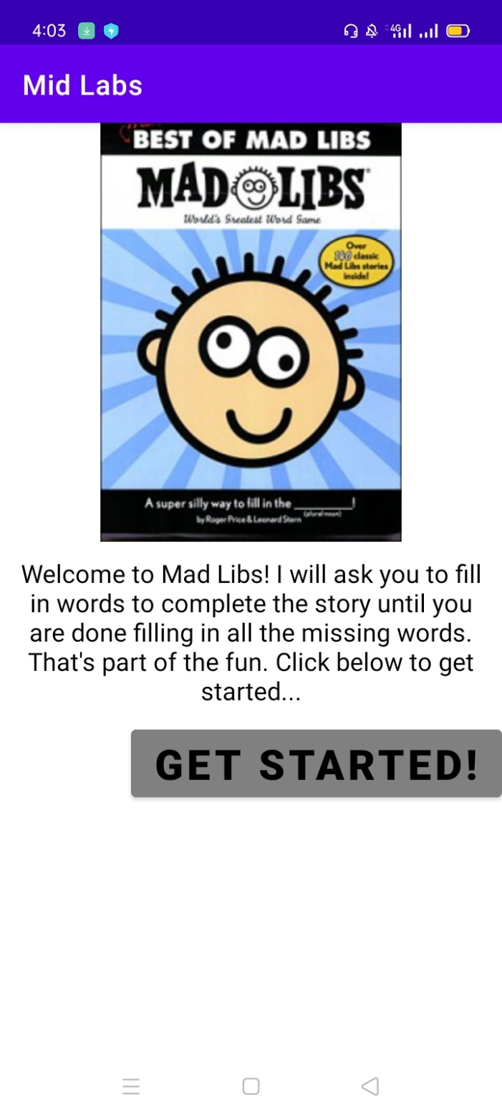

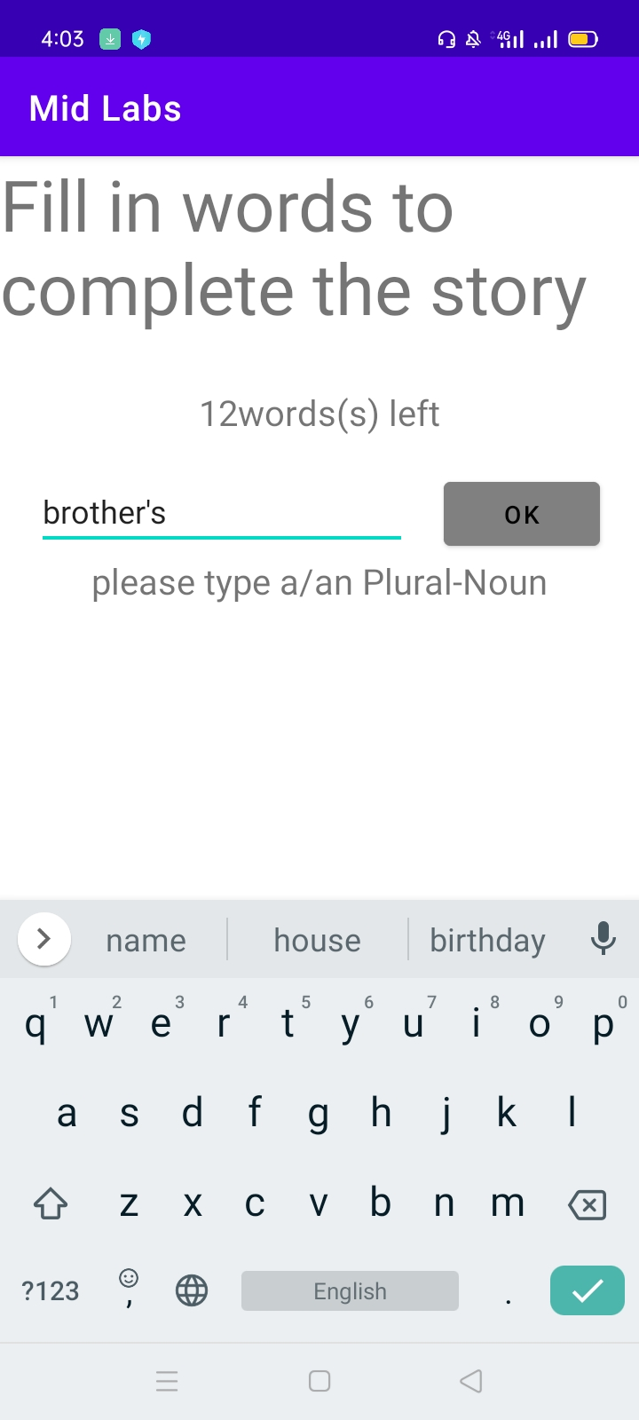

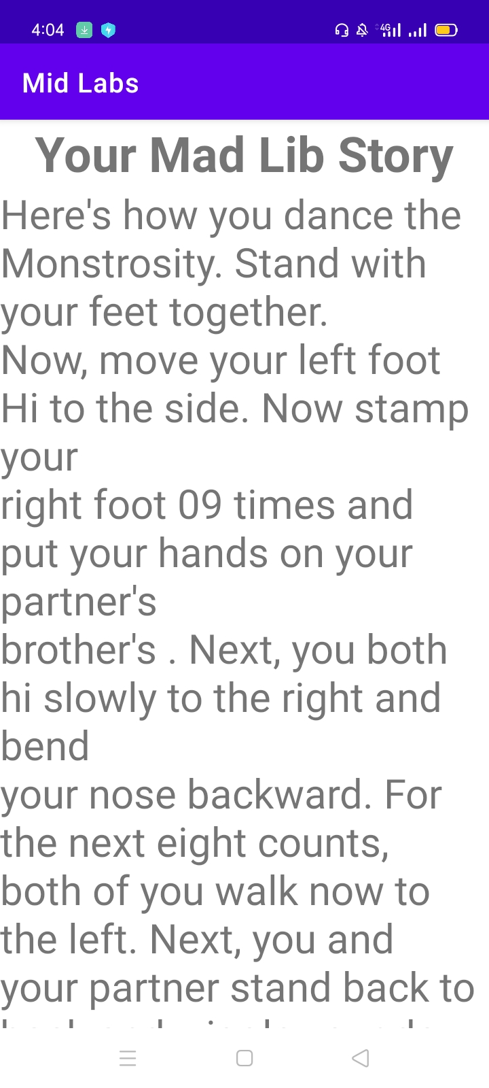

# Activity 2:Add Contacts in Database

## **Layout**

<?xml version="1.0" encoding="utf-8"?>

<LinearLayout xmlns:android="http://schemas.android.com/apk/res/android"

    xmlns:app="http://schemas.android.com/apk/res-auto"

    xmlns:tools="http://schemas.android.com/tools"

    android:layout_width="match_parent"

    android:layout_height="match_parent"

    android:orientation="vertical"

    tools:context=".MainActivity"

    android:padding="30dp"

    >

    <LinearLayout

        android:layout_width="match_parent"

        android:layout_height="wrap_content"

        android:orientation="horizontal"

        android:layout_marginTop="100dp"

        >

        <TextView

            android:layout_width="wrap_content"

            android:layout_height="wrap_content"

            android:layout_weight="0.5"

            android:text="Name" />

        <EditText

            android:id="@+id/text1"

            android:layout_width="wrap_content"

            android:layout_height="wrap_content"

            android:layout_weight="1"

            />

    </LinearLayout>

<LinearLayout

android:layout_width="match_parent"

android:layout_height="wrap_content"

android:orientation="horizontal"

    >

<TextView

    android:layout_width="wrap_content"

    android:layout_height="wrap_content"

    android:layout_weight="0.5"

    android:text="Phone" />

<EditText

    android:id="@+id/text2"

    android:layout_width="wrap_content"

    android:layout_height="wrap_content"

    android:layout_weight="1"

    />

</LinearLayout>

<LinearLayout

android:layout_width="match_parent"

android:layout_height="wrap_content"

android:orientation="horizontal"

    >

<TextView

    android:layout_width="wrap_content"

    android:layout_height="wrap_content"

    android:layout_weight="0.5"

    android:text="Street" />

<EditText

    android:id="@+id/text3"

    android:layout_width="wrap_content"

    android:layout_height="wrap_content"

    android:layout_weight="1"

    />

</LinearLayout>

<LinearLayout

android:layout_width="match_parent"

android:layout_height="wrap_content"

android:orientation="horizontal"

    >

<TextView

    android:layout_width="wrap_content"

    android:layout_height="wrap_content"

    android:layout_weight="0.5"

    android:text="Email" />

<EditText

    android:id="@+id/text4"

    android:layout_width="wrap_content"

    android:layout_height="wrap_content"

    android:layout_weight="1"

    />

</LinearLayout>

<LinearLayout

android:layout_width="match_parent"

android:layout_height="wrap_content"

android:orientation="horizontal"

    >

<TextView

    android:layout_width="wrap_content"

    android:layout_height="wrap_content"

    android:layout_weight="0.5"

    android:text="City/State/Zip" />

<EditText

    android:id="@+id/text5"

    android:layout_width="wrap_content"

    android:layout_height="wrap_content"

    android:layout_weight="1"

    />

</LinearLayout>

<Button

    android:layout_width="wrap_content"

    android:layout_height="wrap_content"

    android:text="Save Contact"

    android:layout_gravity="center"

    android:backgroundTint="@color/teal_700"

    android:onClick="save"

    ></Button>

</LinearLayout>

<?xml version="1.0" encoding="utf-8"?>

<LinearLayout xmlns:android="http://schemas.android.com/apk/res/android"

    xmlns:app="http://schemas.android.com/apk/res-auto"

    xmlns:tools="http://schemas.android.com/tools"

    android:layout_width="match_parent"

    android:layout_height="match_parent"

    android:orientation="vertical"

    tools:context=".database">

    <TextView

        android:layout_width="wrap_content"

        android:layout_height="wrap_content"

        android:layout_gravity="center"

        android:gravity="center"

        android:text="SIBA Database"

        android:textSize="30sp"></TextView>

    <TextView

        android:layout_width="wrap_content"

        android:layout_height="wrap_content"

        android:text="Name : "

        android:id="@+id/name"

        android:padding="30dp"

        ></TextView>

</LinearLayout>

## **Logic Code**

package com.example.addressbook;

import androidx.appcompat.app.AppCompatActivity;

import android.content.Intent;

import android.os.Bundle;

import android.widget.TextView;

public class database extends AppCompatActivity {

    @Override

    protected void onCreate(Bundle savedInstanceState) {

        super.onCreate(savedInstanceState);

        setContentView(R.layout.activity_database);

        Intent intent=getIntent();

        String name=intent.getStringExtra("name");

        TextView text=findViewById(R.id.name);

        DBHelper db=new DBHelper(this,null,null,1);

        text.setText(db.print(name));

    }

}

package com.example.addressbook;

import androidx.appcompat.app.AppCompatActivity;

import android.content.Intent;

import android.os.Bundle;

import android.view.View;

import android.widget.EditText;

public class MainActivity extends AppCompatActivity {

    DBHelper db;

    @Override

    protected void onCreate(Bundle savedInstanceState) {

        super.onCreate(savedInstanceState);

        setContentView(R.layout.activity_main);

        db=new DBHelper(this,null,null,1);

    }

    public void save(View view){

        EditText Name=findViewById(R.id.text1);

        EditText Phone=findViewById(R.id.text2);

        EditText street=findViewById(R.id.text3);

        EditText Email=findViewById(R.id.text4);

        EditText city=findViewById(R.id.text5);

        db.insert(Name.getText().toString(),Phone.getText().toString(),

                street.getText().toString(),Email.getText().toString(),city.getText().toString());

        Intent intent=new Intent(this,database.class);

        intent.putExtra("name",Name.getText().toString());

        startActivity(intent);

    }

}

## **SQliteOpenHelper Class:**

package com.example.addressbook;

import android.content.ContentValues;

import android.content.Context;

import android.database.Cursor;

import android.database.sqlite.SQLiteDatabase;

import android.database.sqlite.SQLiteOpenHelper;

import androidx.annotation.Nullable;

public class DBHelper  extends SQLiteOpenHelper {

    public DBHelper(@Nullable Context context, @Nullable String name, @Nullable SQLiteDatabase.CursorFactory factory, int version) {

        super(context, "SIBA.db", factory, 1);

    }

    @Override

    public void onUpgrade(SQLiteDatabase db, int oldVersion, int newVersion) {

        db.execSQL("DROP TABLE IF EXISTS info");

        onCreate(db);

    }

    @Override

    public void onCreate(SQLiteDatabase db) {

        String query="CREATE TABLE info (Name TEXT,Phone TEXT,Street TEXT,Email TEXT,City Text);";

        db.execSQL(query);

    }

    public void insert(String Name,String Phone,String Street,String Email,String City){

        ContentValues  values=new ContentValues();

        values.put("Name",Name);

        values.put("Phone",Phone);

        values.put("Street",Street);

        values.put("City",Name);

        values.put("Email",Email);

        SQLiteDatabase db=getWritableDatabase();

        db.insert("info",null,values);

        db.close();

    }

    public String print(String name){

        String string="";

        SQLiteDatabase db=getWritableDatabase();

        String query="SELECT * FROM info WHERE Name=\""+name+"\";";

        Cursor c=db.rawQuery(query,null);

        c.moveToFirst();

        while (!c.isAfterLast()){

            if(c.getString(c.getColumnIndex("Name"))!=null)

                string+=c.getString(c.getColumnIndex("Name"));

            c.moveToNext();

            break;

        }

        db.close();

        return  string;

    }

}

## **Output**

